Advanced C Programming

Prashanth. S (19MID0020)

|  |
| --- |
| **Cloud Computing** |
| Cloud is about how you do computing, not where you do computing -- Paul Maritz |
| **Cloud computing**is the on-demand availability of [computer](https://en.wikipedia.org/wiki/Computer) [system resources](https://en.wikipedia.org/wiki/System_resource), especially data storage ([cloud storage](https://en.wikipedia.org/wiki/Cloud_storage)) and [computing power](https://en.wikipedia.org/wiki/Computing_power), without direct active management by the user. The term is generally used to describe [data centers](https://en.wikipedia.org/wiki/Data_center) available to many users over the [Internet](https://en.wikipedia.org/wiki/Internet). |
| Prashanth S (19MID0020) |

|  |  |  |  |
| --- | --- | --- | --- |
|  |  |  |  |

Cloud Computing Introduction

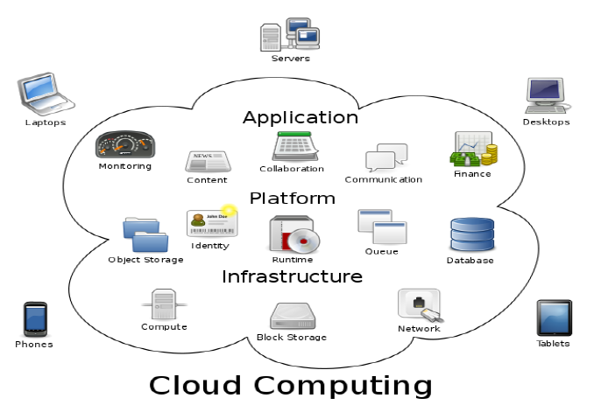

Cloud Computing is a very general term used to describe a new class of network and web based computing that takes place over the Internet, basically a step on form utility. By using the internet and central remote services cloud computing maintains the data, applications etc which offers much more efficient computing by centralizing storage, memory, processing bandwidth and so on. It can also concentrate on all computational resources and manage automatically through the software without intervenes.

As the client acknowledge the data request to the server, the request is being processed and finally search results return. But, it is exigent to actualize the measurement and monitoring, to accomplish the quality of service and burgeoning of efficient resource allocation and efficiency of resource.

Need for Cloud Computing

* One of the major reason why very huge number of small scale and large scale business sectors from all over the world are using cloud today, is because cloud computing has tremendous effect on **cost saving**.
* Yes, Cloud computing has made drastic change in the reduction of hardware and software cost and other server resources as well since the vendors will provide all the requirements to the customer at very low cost.
* We can run all our workload data of applications and processes online over the internet remotely instead of using physical hardware and software.
* Day to day issues related to server maintenance or installation of software/ hardware or whether it is renewal of license, all those factors are undertaken via cloud computing service providers.
* With the help of cloud we can access any data, applications whenever and wherever we want to, over the internet. 100 of pre-configured applications can be install and updated.
* Cloud not only handles data storage remotely but it also protects and recovers all crashed or loss data, so we don’t have to worry about crashed or loss of data, it gives you high security.

Self-Managed vs Managed data-bases

**Self-Managed databases**

In this cloud offering, the vendor provides just the hardware, the hypervisor to run your VM, and the API or other tools to manage deployment. You need to create a VM running an operating system and your application. Obviously, you can run anything you want in the VM, including a database engine of your choice. You need to perform most of the administrative tasks yourself, such as installing updates and configuring all of the networking options.

If we use a managed database, we don’t need to manually download, install, update, configure, or back up the database. the cloud provider does all of that. We can still modify parameters that instruct the database how to run (collation, cursors, connections, etc.) and control decisions such as whether to install new releases and how long to retain backups.

**Managed databases**

In this cloud offering, the vendor provides not only hardware but also the server software itself. Most vendors offer both traditional databases (such as Oracle and MySQL) and cloud native databases (AWS, Azure and Google cloud ) that are specific to that vendor.

Sometimes, the cloud vendor can provide a license for a proprietary database and include the cost with the cost of using the cloud service. In other cases, you are still responsible for obtaining a license. If you already purchased a license from a proprietary database vendor, you can sometimes apply that to a managed database.

Types of Cloud Computing

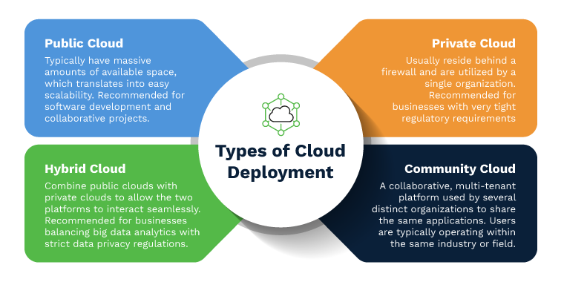

## Public cloud

## Public clouds are owned and operated by a third-party [cloud service providers](https://azure.microsoft.com/en-us/overview/choosing-a-cloud-service-provider/), which deliver their computing resources, like servers and storage, over the Internet. These services can be used by common people who have access to internet. Amazon Web Service, Google cloud and Microsoft Azure is an example of a public cloud. With a public cloud, all hardware, software, and other supporting infrastructure is owned and managed by the cloud provider.

## Private cloud

A private cloud refers to cloud computing resources used exclusively by a single business or organization. A private cloud can be physically located on the company’s on-site datacenter. Some companies also pay third-party service providers to host their private cloud. A private cloud is one in which the services and infrastructure are maintained on a private network.

## Hybrid cloud

Hybrid clouds combine public and private clouds, bound together by technology that allows data and applications to be shared between them. By allowing data and applications to move between private and public clouds, a hybrid cloud gives your business greater flexibility, more deployment options, and helps optimize your existing infrastructure, security, and compliance.

Types of Cloud Services

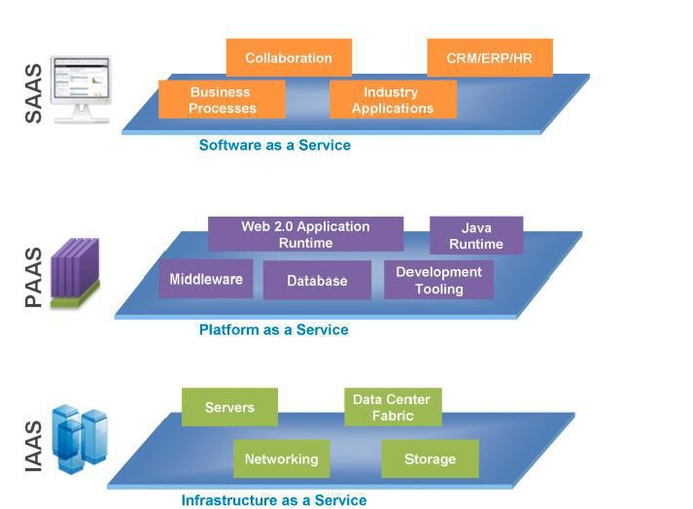

Infrastructure as a Service [IaaS]

The most basic category of cloud computing services. With IaaS, it is possible to rent IT infrastructure—servers and virtual machines (VMs), storage, networks, operating systems—from a cloud provider on a pay-as-you-go basis.

Platform as a Service [PaaS]

Platform as a service refers to cloud computing services that supply an on-demand environment for developing, testing, delivering, and managing software applications. PaaS is designed to make it easier for developers and entrepreneurs to quickly create web or mobile apps, without worrying about setting up or managing the underlying infrastructure of servers, storage, network, and databases needed for development.

Serverless computing

Overlapping with PaaS, serverless computing focuses on building app functionality without spending time continually managing the servers and infrastructure required to do so. The cloud provider handles the setup, capacity planning, and server management for you. Serverless architectures are highly scalable and event-driven, only using resources when a specific function or trigger occurs.

Software as a Service [SaaS]

Software as a service is a method for delivering software applications over the Internet, on demand and typically on a subscription basis. With SaaS, cloud providers host and manage the software application and underlying infrastructure, and handle any maintenance, like software upgrades and security patching. Users connect to the application over the Internet, usually with a web browser on their phone, tablet, or PC.

Implementation

Here the C code is written on our mobile devices (based on android operating system) /web-pages. These programs are compiled in the server and the results are stored in the cloud storage and displayed on the respective user’s device.

Android is a software stack for mobile devices that includes an operating system, middleware and key applications. The Android SDK provides the tools and APIs necessary to begin developing applications on the Android platform using the Java programming language.

The complier for C programming language is known as the C complier, whereas Cloud C compiler compiles the program which are run with the help of Cloud computing. The primary function of complier is to reform one code into the other like translator. Compiler work by taking the c program code and compile it into assembler, which is then assembled into bit code which is the only language that the CPU understands.

Development of C Compiler for mobile devices or notebooks is a very complex task. So a Cloud C Compiler through which the C programs can be created, compiled and executed using the internet. It is recommended that the GCC/C Libraries are installed on the server. So JSP and Servlets for Server side programming and used Android SDK for developing an android application which communicate with the server and then create , compile & execute the C program.

**Entire project perspective**

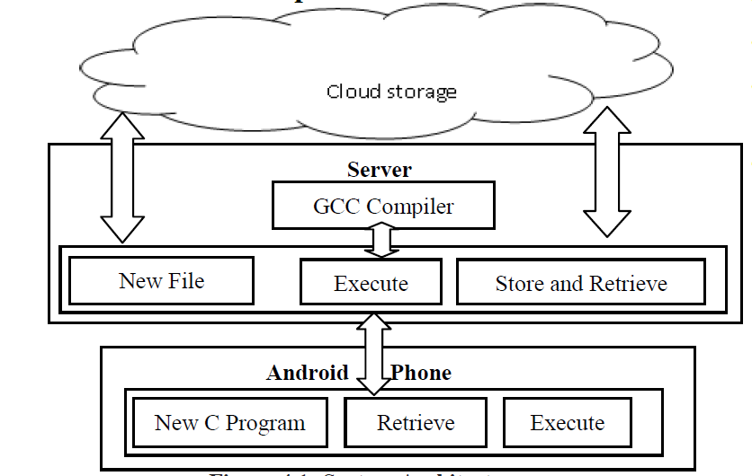

This is the entire project outline.  
The interface is residing on the mobile phone.  
C Compiler is stored in the server.

**Data Flow Diagram**

Initial steps of logging in and user verification.

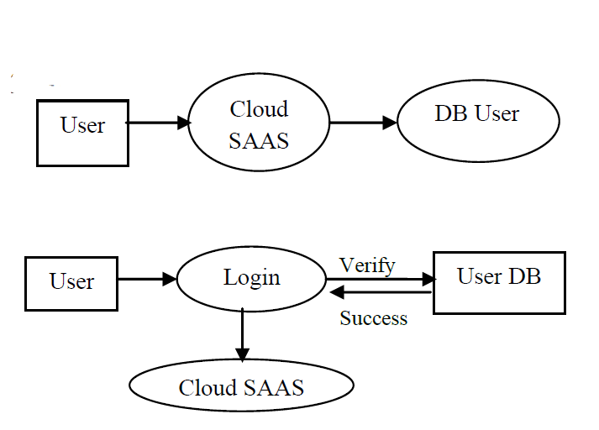 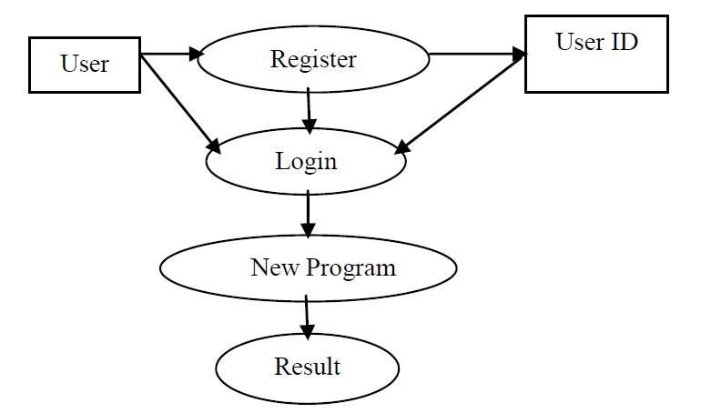

**Working of Cloud C Compiler**

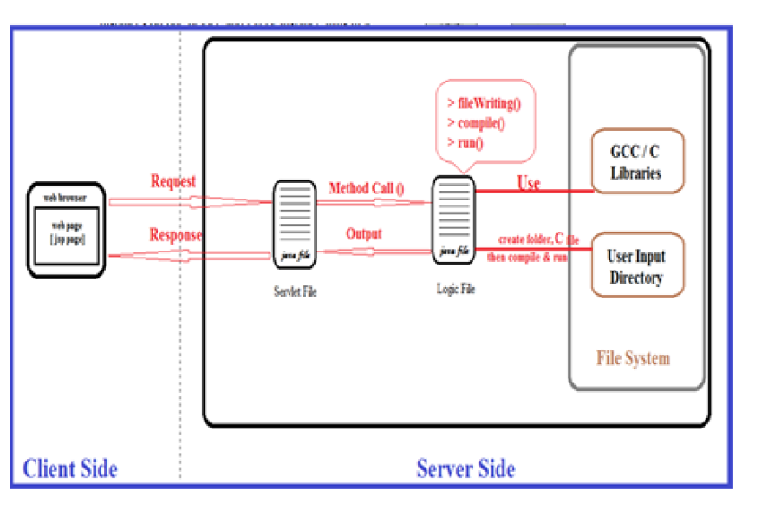

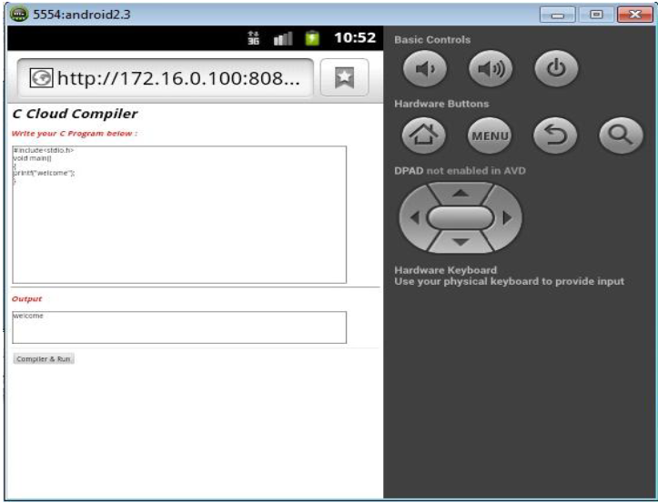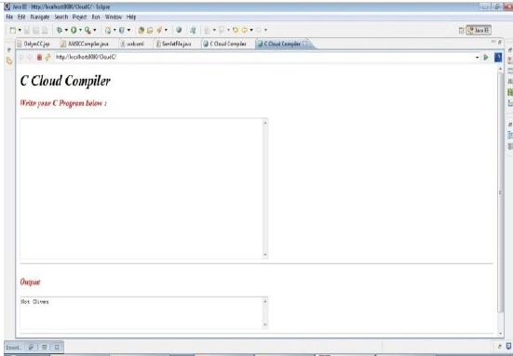

**Android Emulator Local Host**

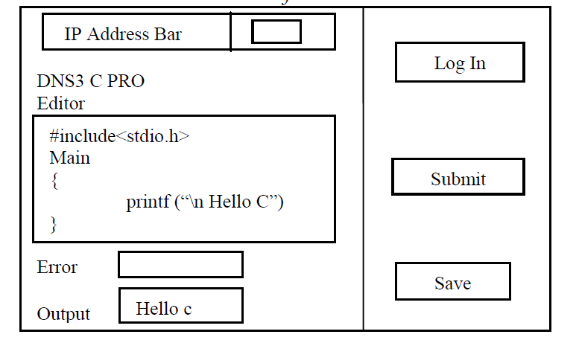 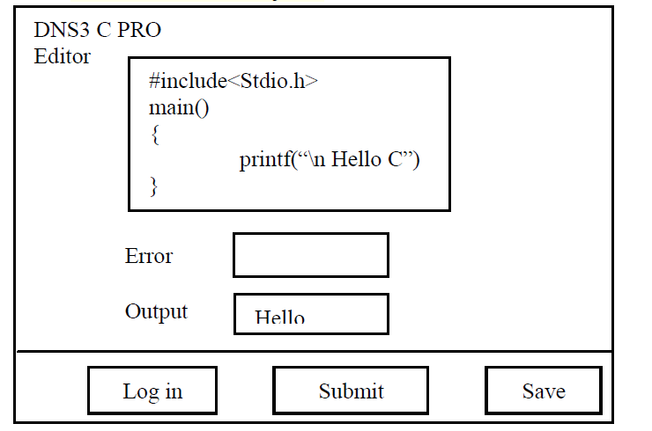

**Android phone interface Web browser interface**

* Initially the user must login.
* After typing the code, then the user must click the submit button.
* The program is sent to the server, and GCC compiler in the server will process the code and throw the error if there or else the output.
* The output is stored in the cloud storage and sent also back to the user.  
  The user gets the output in their respective interface.

**Reference**

* <https://azure.microsoft.com/en-us/overview/what-is-cloud-computing/#cloud-deployment-types>
* <https://www.geeksforgeeks.org/why-cloud-computing-is-important-in-data-science/>
* <https://en.wikipedia.org/wiki/Cloud_computing>
* <https://www.google.com/url?sa=t&rct=j&q=&esrc=s&source=web&cd=&ved=2ahUKEwjEvPPrjsfwAhWfxTgGHYo4BMsQFjAEegQIFRAD&url=https%3A%2F%2Fciteseerx.ist.psu.edu%2Fviewdoc%2Fdownload%3Fdoi%3D10.1.1.695.2740%26rep%3Drep1%26type%3Dpdf&usg=AOvVaw16fBhoXlKkfLS-_ekGeD6q>